

**Report No#01**

**Name: Zahra Batool**

**Submitted to: Sir Yasir**

**Class: BSCS (30-B)**

**Roll No# UET-18F-BSCS-19 (F-59088)**

**Emerging Web Technology in 5 years**

The future is always an exciting place and with technology trends accelerating expeditiously – the concept of universal digital transformation seems to become a reality soon. Technology has completely revolutionized the way we do business and are steering forward across different industries from banking to healthcare and e-commerce.  . Looking up to future Technics and envisioning the possibilities makes this era of innovations more exciting. It was just a while back when we got into the flow of current software trends, and now the advancements are already gearing up to shake the business world. Each of these emerging or we can say, prominent technologies are maturing at different rates. However, Artificial Intelligence, Voice Technology, Machine Learning, etc. have been there for quite a few years. But their rapid growth elevated potential, and innovations always led them to be in the category of rising technologies***.*** While many discoveries around some existing Technics are already taking center stage. Let us explore the **types of emerging technologies** that are worth investing. The 5 emerging technologies that are promising enough to generate a competitive advantage for companies over the next six to ten years.



**1.Internet of Things (IoT)**

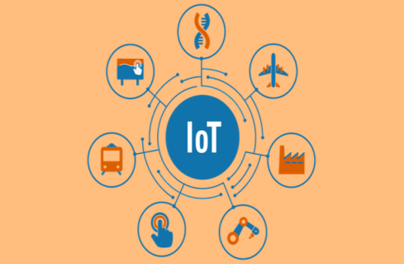Iot has been one of the most captivating technologies around and still continues to hold its place. Currently, almost 9 billion devices connected to the Internet, and it would not be unreasonable to expect this number to rise to a whopping 20 billion by the upcoming year. This concept has been very instrumental in smart home innovation. It has also made possible for devices like Alexa and Google Home to function. In 2020 the Internet of things will consider more functionality and control to allow vaster integration of different aspects of the smart home. Its utilization will expand gigantically in the future as most of the things around us will get smart soon. Well-known companies like Apple and Samsungare also coming up with their products with this technology to give Alexa and Google Home a competition.

## 2.Artificial Intelligence (AI) and Analytics.

AI refers to the computers having the capabilities of performing tasks like a human.Its precision and benefits have made it so popular among organizations to leverage this technology. the availability of enormous data is allowing the AI to develop at a rapid speed, and a lot of significant advances will be seen in its algorithm in the future. But very soon, the level of advancement of AI will get so high that machines will take over all the human tasks. The brand also announced recently its plan to open 3000 Amazon Go stores in different locations of the country by 2021.So ultimately we can assume that AI will be in all aspects of our lives by 2020, whether shopping, business, transportation, banking, healthcare, or any other sectors.

## 3.5G Connectivity

## This technology is all set to get launched by the mid of next year and will definitely see a tremendous amount of implementations. The world’s largest telecommunication companies Qualcomm, Huawei, AT&T, Verizon, and Nokia are making sure, to keep their deployment of 5G technology on pace. The manufacturers are also ready to come out with more 5G phones. In addition to this, WiFi 6 is also in its developing stage and soon to be released in the market. Both of these technologies will drastically enhance the wireless communication protocol and accelerate business development.

## 4. Voice Technology

Voice is something that cannot be easily translated into digital technology. It is a medium that tends to be free-flowing and organic.As Artificial Intelligence and Computer Learning Programs are growing, voice creating software is also escalating towards a more human-paralleled realm.Soon, voice commands and smart devices around us will prove even more useful in our day to day lives.Neuro-Linguistic Programming (NLP) is one prominent aspect of voice technology that will allow systems and computers to better comprehend the true essence of voice.This new programming language will bring more understanding to computers about human tone, puns, sarcasm, and even more profound clues like double meanings.